|  |
| --- |
| **Toy** |
| toy_ID |
| name |
| price |

|  |
| --- |
| **Toy_Teddy** |
| toy_ID |
| material |
| age |

|  |
| --- |
| **Toy_Car** |
| toy_ID |
| enging_size |
| Petrol_or_diesel |

I would have a toy table with the unique toy_ID as the primary key and then separate tables for the type of toy, all with toy_ID as a foreign, primary key.

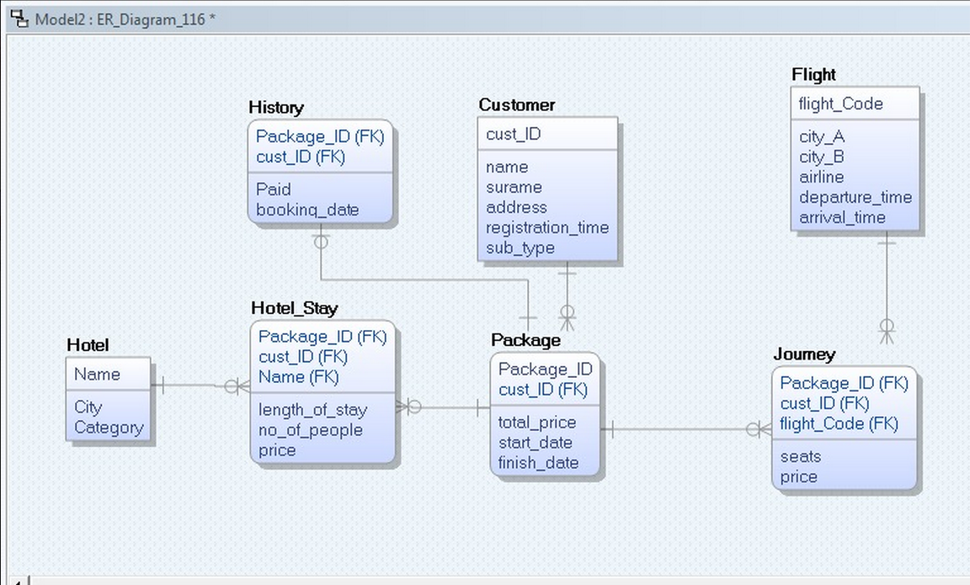

3. a. Check (1<= Category AND Category <= 5);  
 b. Check (0 < total_price AND total_price< 100000);  
 c. Check (sub_type = “p” Or sub_type=”s”);

4. Select * From Hotel   
 Inner Join Hotel_Stay  
 on Hotel.name= Hotel_Stay.name  
 Where Category =3;